

Project ,,Georgian-Norwegian Collaborative in Public Health (GeNoC-PH)’’

Mid-Term Conference
Lopota Lake May 4 and May 7 - 2018

 |  | 

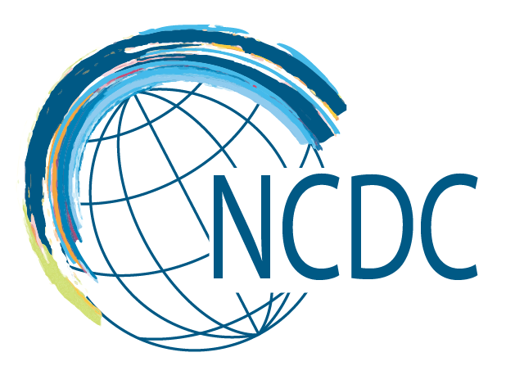 |  | 

Participants’ list
- Adamia, Eka (MoH)
- Anda, Erik Eik (UiT)
- Borch, Kristin (UiT)
- Chikhladze, Nino (TSU)
- Darakhvelidze, Marina (MoH)
- Darchia Irine (TSU)
- Daulaire, Nils (UiT)
- Ezugbaia, Vazha (CiTi)
- Gamkrelidze, Amiran (NCDC)
- Goksadze, Elene (NCDC)
- Hasvold, Toralf (UiT)
- Imnadze, Paata (TSU)
- Jangirashvili, Archil (UG)
- Jorbenadze, Maka (TSU)
- Kandelaki, Levan (NCDC)
- Kazhakhashvili, Nata (TSU)
- Kereselidze, Maia (NCDC)
- Khatia Antia (UG)
- Khvichia, Vakho (CiTi)
- Kintraia, Nikoloz (GOGPA)
- Kordzaia, Dimitri (TSU)
- Lagvilava, Maia (MoH)
- Landia, Natia (UG)
- Lobjanidze, Mariam (UG)
- Lobjanidze, Tamar (UG)
- Lobzhanidze, George (TSU)
- Lorentzen, Tor Gisle (UiT)
- Manjavidze, Tinatin (UiT)
- Mollersen, Kajsa (UiT)
- Nedberg, Ingvild Hersoug (UiT)
- Oboladze, Lia (NCDC)
- Pitskhelauri, Nato (TSU)
- Qachlishvili, Natalia (NCDC)
- Roelofs, Sandra Elisabeth (UG)
- Shengelia, Lela (NCDC)
- Skhvitaridze, Natia (UiT)
- Sturua, Lela (NCDC)
- Taylor, Mary (UiT)
- Turdziladze, Aleqsander (NCDC)
- Tvaliashvili, Mariam (NCDC)
- Ugulava, Tako (UNICEF)
- Urushadze, Ramaz (UG)
- Vasadze, Otar (UG)
- Wæhler, Turid (UiT)

Agenda

Friday, May 4
Time | Module | Description
05:00 |  | Norwegians arrival from in Tbilisi  Transport directly to Lobota Lake with minubus
14.00-16.00 |  | Georgians who are participating in preliminary meetings arrive from Tbilisi  Bus transport is organized
16.00-20.00 |  | Preliminary meetings:  - Economy – SiU project  - Master/exchange  - Project in general
20.00 | Joint Dinner

Saturday May 5
Time | Module | Description
09.00 | Breakfast | In hotel restaurant
10.00 - 10.30 | Welcome and introductions/updates | Nino/Tamar
10.30 – 11.00 | Presentation by Amiran Gamkrelidze | Status and update
11.00-11.30 | Erik Anda | Update of the scientific part of the project
11.30-11.45 | Short break
11.45-12.45 | Presentation by Mary Taylor | What can registered health information be used for?
12.45-13.00 | Questions and short discussions
13.00-14.00 | LUNCH
14.00 -15.00 | Presentation by Nils Daulaire | Global Health Security in the Caucasus
15.00 – 16.30 | Presentation by PhD students  Very short overview + status on article 1 | 20 min presentation + 10 min discussion for each
16.30 – 17.00 | Coffee break
17.00 – 18.30 | Plenary discussions | Round table plenary discussions  - How is the program doing?  - How can it be improved  - What is next?  With external evaluators!
19.00 | Joint dinner

Sunday May 6
Time | Module | Description
09.00 – 10.00 | Breakfast | In hotel restaurant
10.00-10.30 | Presentation from Kristin Borch | Internationalization and exchange from UiT’s standpoint
10.30-11.15 | Presentation by Toralf Hasvold | “The risk of being born”
11.15-11.30 | Short break
11.30-12.00 | Presentation by TSU
12.00-12.30 | Presentation by UG
12.30-13.00 | Presentation by Erik | The success of breastfeeding at hospital discharge (Marie Sigstad)
13.00-14.00 | LUNCH
14.00 -15.00 | Closing remarks/discussions | Round table discussions
15.00 – 18.00 | Board meetings | - Economy  - Master  - Project etc.
19.00 | Dinner
00.00? | Departure for those Norwegians leaving early | Transport to airport

Monday May 7
Time | Module | Description
09.00 | Breakfast | In hotel restaurant
10.00 | Departure to Tbilisi for the remaining participants

